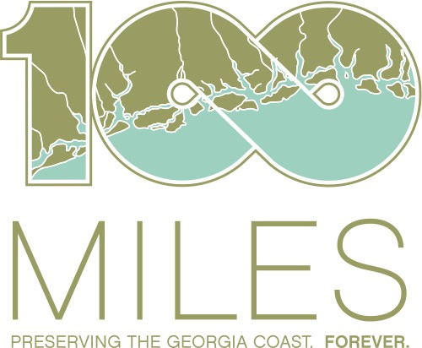

YELP Part-Time Assistant

One Hundred Miles (OHM) is a nonprofit with a mission of protecting and preserving Georgia’s 100-mile coast through advocacy, education, and citizen engagement.

OHM is seeking a part-time YELP Assistant to provide support for our Youth Environmental Leadership Program (YELP) for the 2024-25 school year. YELP is designed to engage and empower high school-aged students to take action for Georgia’s 100-mile coast. The 6th year of our program, currently underway, runs from September 2024 through May 2025 and engages students through coastal field trips, workshops, and service-learning opportunities. The YELP Assistant will be responsible for transporting participants to and from pick-up sites in the Savannah area and field trip locations across the coast, acting as a mentor to YELP participants, and assisting OHM staff during monthly field trips and group meetings.

Responsibilities may vary, but major tasks include:

* Safely drive students via rental minivan to and from field trip sites (1 Saturday per month)
* Assist YELP Coordinator and other OHM staff with field trip logistics and other program needs
* Engage YELP participants during monthly field trips, workshops, and service-learning opportunities
* Act as a role model and mentor to YELP participants
* Other duties as assigned by OHM staff

**Required Skills and Qualifications**

We are looking for a talented and driven individual to accelerate our efforts and have the ability to start immediately. The successful candidate must have:

* Valid driver’s license and clean driving record; extremely responsible and punctual
* Over age 25 preferred (for van rental purposes)
* Experience working with youth
* Excellent communication skills
* Knowledge of coastal ecosystems and environmental conservation issues in coastal Georgia is a plus
* Sense of humor, flexibility, and positivity

This part-time, hourly position requires an average commitment of approximately 10-15 hours each month, including one Saturday per month, starting in September 2024 (or soon thereafter) and running through May 2025. This position will be based in or around Savannah, with frequent travel to various locations across Georgia’s coast. The YELP Assistant must pass a criminal background and driving check.

If you are interested in this position, please send a resume and/or letter of interest summarizing your qualifications and experience to Stephanie Chewning, YELP Coordinator and Coastal Education Coordinator, at [stephanie@onehundredmiles.org](mailto:stephanie@onehundredmiles.org) or 201-960-7066. One Hundred Miles is an equal-opportunity employer.